Parth Babbar

9999940289  kishibabbar@gmail.com

Banking system globalization

**Banking System Globalization:**

**Introduction:**

Globalisation of the banking sector involves expanding banks outside their national borders, therefore connecting financial markets and services internationally. In the United States, technological improvements, reform, and the global economy's expanding relationships have all had significant effects on this process. The involvement of large US banks such as JPMorgan Chase and Citibank in overseas markets, as well as foreign bank contact into the United States, demonstrates this pattern of growth.

**Historical Background:**

1. **Early International Banking(19th Century):** US banks began their worldwide development in the late 19th century, driven by the need to assist American businesses abroad.  
   
2. **Post-World War II Era:** The Bretton Woods Agreement of 1944 established a new international monetary system, which resulted in increasing international financial cooperation and the development of US banks overseas.  
   
3. **1990s to Present:** Advances in technology and increased reform have contributed to the globalisation of US banks.  
     
   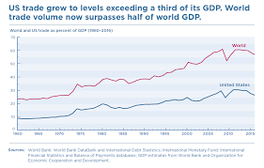

**What helped in Globalization?**

1. **Technological Advancements:** The growth of fintech, digital banking, and internet transactions has made cross-border financial operations more efficient. Blockchain, artificial intelligence, and big data analytics have enabled banks to provide seamless worldwide services.
2. **Increase in Cross-Border Trade & Investments:** Banks are now more widely present around the world as a result of international business and investment support brought about by trade agreements and economic alliances.  
   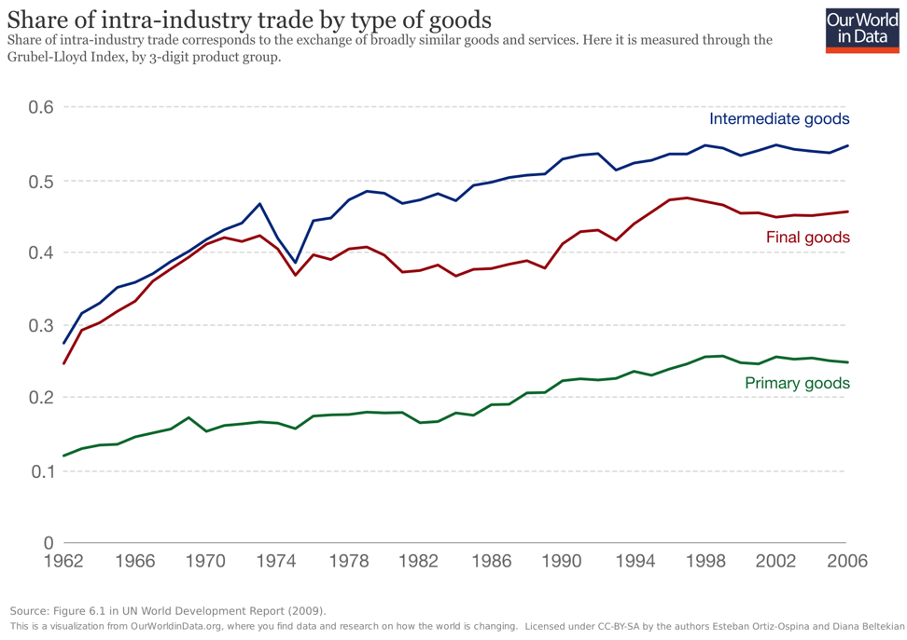
3. **Global Economic Integration:** The integration of global economies has opened up chances for banks to service multinational firms and people with international financial requirements.

**Impacts on US Banks:**

1. **Expansion into International Markets:** US banks have expanded their global reach by opening branches, subsidiaries, and forming partnerships throughout the world.  
   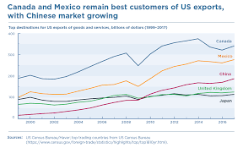
2. **Entry of Foreign Banks into US Markets:** Foreign banks, drawn to the enormous and profitable US market, have established operations in the country, enhancing competition and providing a variety of services.

If there are some benefits from Globalization that it means there might be some challenges too:

1. **Benefits:** Operating in several countries allows US banks to diversify their income sources, decreasing reliance on the home market and lowering risks. Furthermore, worldwide operations generate economies of scale, allowing banks to cut costs and improve efficiency. This increases their competitiveness by broadening their reach and reputation on the global arena, establishing them as creative and dependable financial institutions capable of serving a diversified client.
2. **Challenges:** Navigating multiple regulatory frameworks is a big problem for US banks operating abroad, since requirements for compliance vary by country, increasing complexity and expense. Furthermore, knowing and adapting to differed cultural norms is critical for success in global markets, since successful communication and relationship-building are dependent on cultural sensitivity and knowledge. Furthermore, political risks like as instability and regulatory changes in other nations endanger international business, demanding proactive risk management measures to mitigate such disruptions.

**Case Studies:**

I would like to give examples of 2 major contributors of making Globalization take place in US baking sector:

1. **JPMorgan Chase:** With operations in over 60 countries, JPMorgan Chase has used its worldwide reach to provide a diverse variety of financial services, including investment banking and asset management.
2. **CitiBank:** Citibank is well-known for its broad international network, serving clients in over 160 countries with services including consumer banking, business banking, and wealth management.

**Which Regulatory Firm backed up?**Regulatory authorities such as the Federal Reserve and the OCC regulate US banks, ensuring that they follow local and international regulations. Basel III regulations, which aim to strengthen capital requirements, will have a substantial impact on worldwide operations. Furthermore, stringent adherence to anti-money laundering (AML) and know-your-customer (KYC) regulations is critical for preventing financial crimes and maintaining confidence in the global banking industry.

**Conclusion:**

The globalisation of the United States financial sector has resulted in various benefits, including enhanced revenue diversification and competitiveness. However, it also raises issues like as regulatory compliance and political threats. To sustain their competitive advantage in the future, US banks must continue to adapt to the rapidly changing global marketplace.